Central African Republic

## Freedom House political status

The data set shows the Freedom House political scores and status of the country each year.

## # A tibble: 19 x 5  
## country iso3c date mean status   
## <chr> <chr> <dbl> <dbl> <chr>   
## 1 Central African Republic CAF 1996 4 Partly Free  
## 2 Central African Republic CAF 1998 3.5 Partly Free  
## 3 Central African Republic CAF 2000 3.5 Partly Free  
## 4 Central African Republic CAF 2002 5 Partly Free  
## 5 Central African Republic CAF 2003 6 Not Free   
## 6 Central African Republic CAF 2004 5.5 Not Free   
## 7 Central African Republic CAF 2005 4.5 Partly Free  
## 8 Central African Republic CAF 2006 4.5 Partly Free  
## 9 Central African Republic CAF 2007 5 Partly Free  
## 10 Central African Republic CAF 2008 5 Partly Free  
## 11 Central African Republic CAF 2009 5 Partly Free  
## 12 Central African Republic CAF 2010 5 Partly Free  
## 13 Central African Republic CAF 2011 5 Partly Free  
## 14 Central African Republic CAF 2012 5 Partly Free  
## 15 Central African Republic CAF 2013 7 Not Free   
## 16 Central African Republic CAF 2014 7 Not Free   
## 17 Central African Republic CAF 2015 7 Not Free   
## 18 Central African Republic CAF 2016 7 Not Free   
## 19 Central African Republic CAF 2017 7 Not Free

## Freedom House classification of political change

The data set shows the GDP growth and the ecomic growth classification of the country each year.

## # A tibble: 19 x 4  
## country iso3c date politicalChangeFH  
## <chr> <chr> <dbl> <chr>   
## 1 Central African Republic CAF 1996 no change   
## 2 Central African Republic CAF 1998 democratization   
## 3 Central African Republic CAF 2000 no change   
## 4 Central African Republic CAF 2002 no change   
## 5 Central African Republic CAF 2003 autocratization   
## 6 Central African Republic CAF 2004 democratization   
## 7 Central African Republic CAF 2005 democratization   
## 8 Central African Republic CAF 2006 no change   
## 9 Central African Republic CAF 2007 autocratization   
## 10 Central African Republic CAF 2008 no change   
## 11 Central African Republic CAF 2009 no change   
## 12 Central African Republic CAF 2010 no change   
## 13 Central African Republic CAF 2011 no change   
## 14 Central African Republic CAF 2012 no change   
## 15 Central African Republic CAF 2013 autocratization   
## 16 Central African Republic CAF 2014 no change   
## 17 Central African Republic CAF 2015 no change   
## 18 Central African Republic CAF 2016 no change   
## 19 Central African Republic CAF 2017 no change

## Freedom House score trend

The plot shows the Freedom House scores trend of the country.

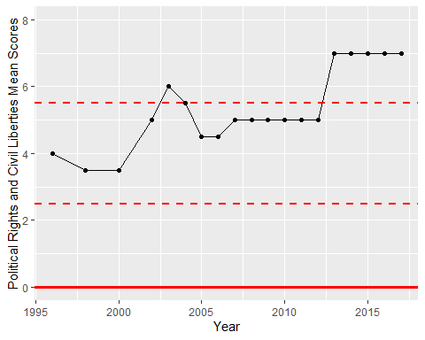

Freedom House Score Trend